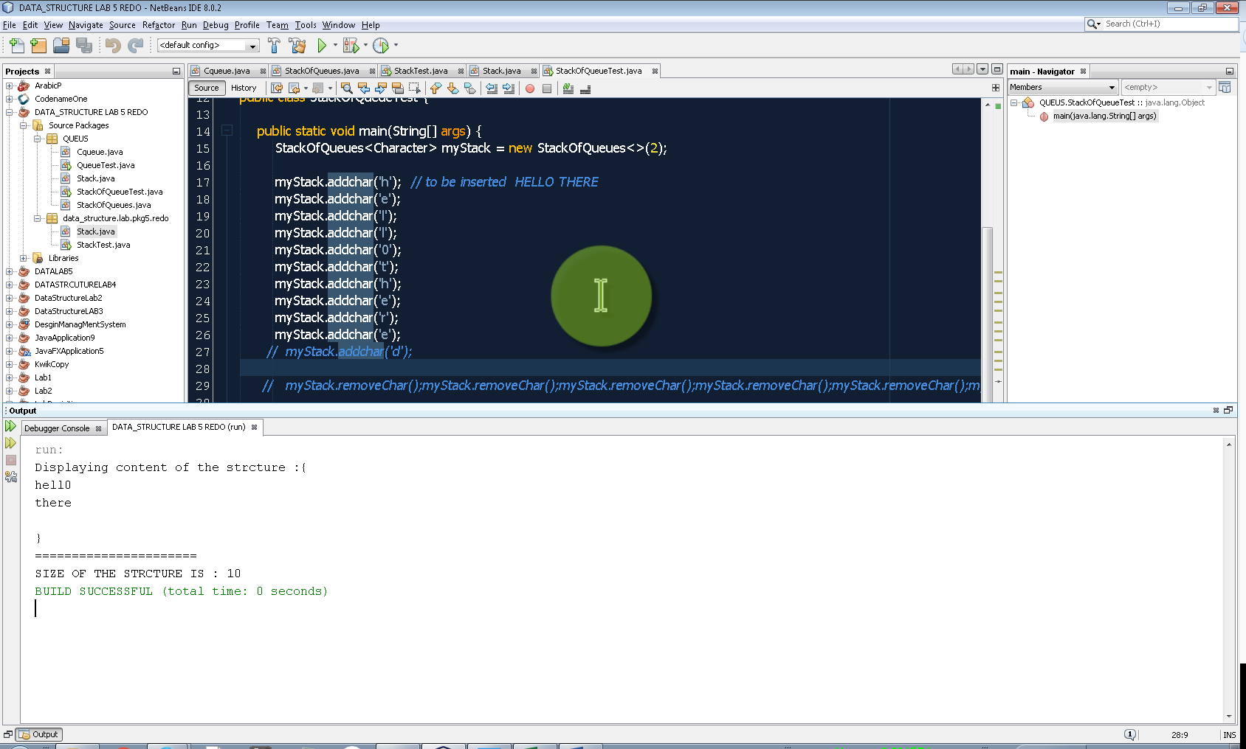Question 1 : testing the addChar normal Case.

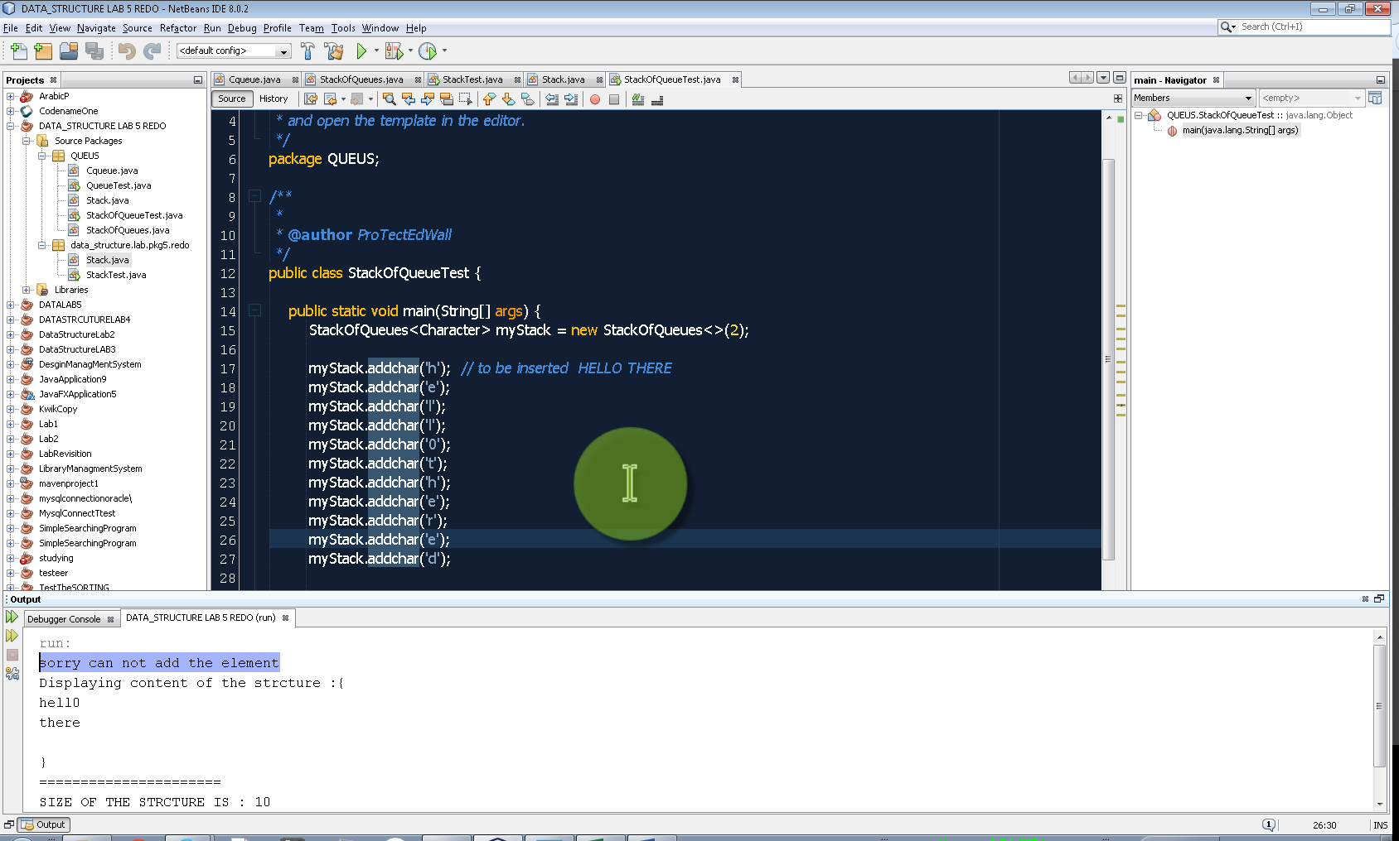Question 1 exceptional case: adding more characters than required . so I display a messege

Question 2 : removing character normal case

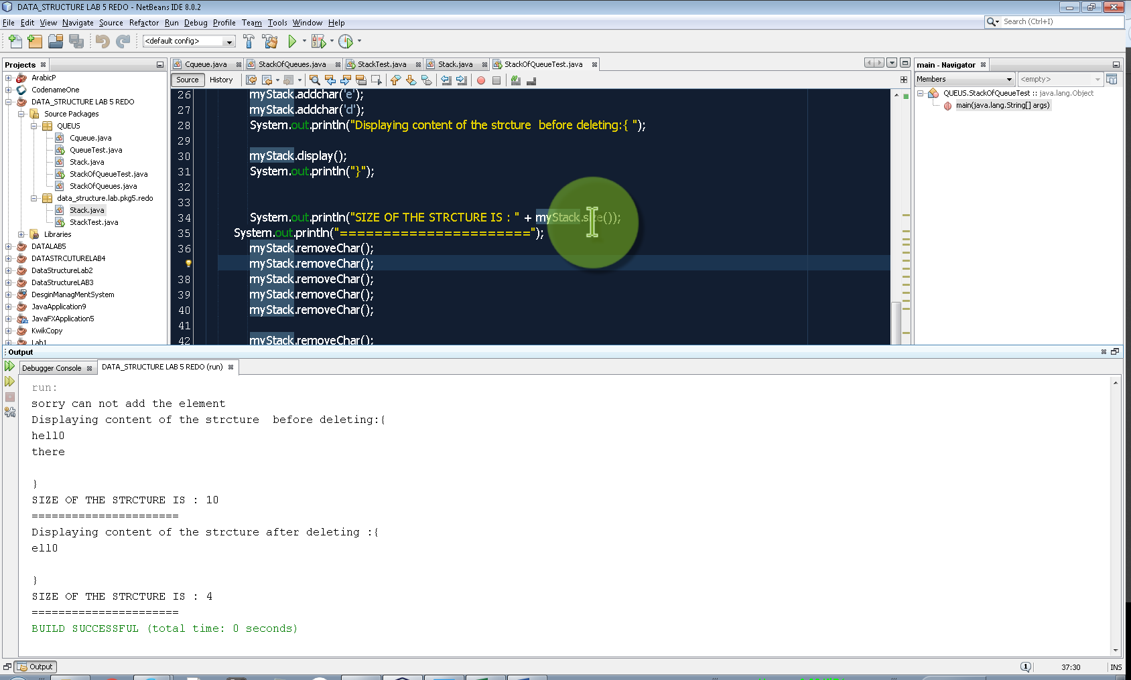

Question 2-exceptional case , removing chars more than it is in the stack

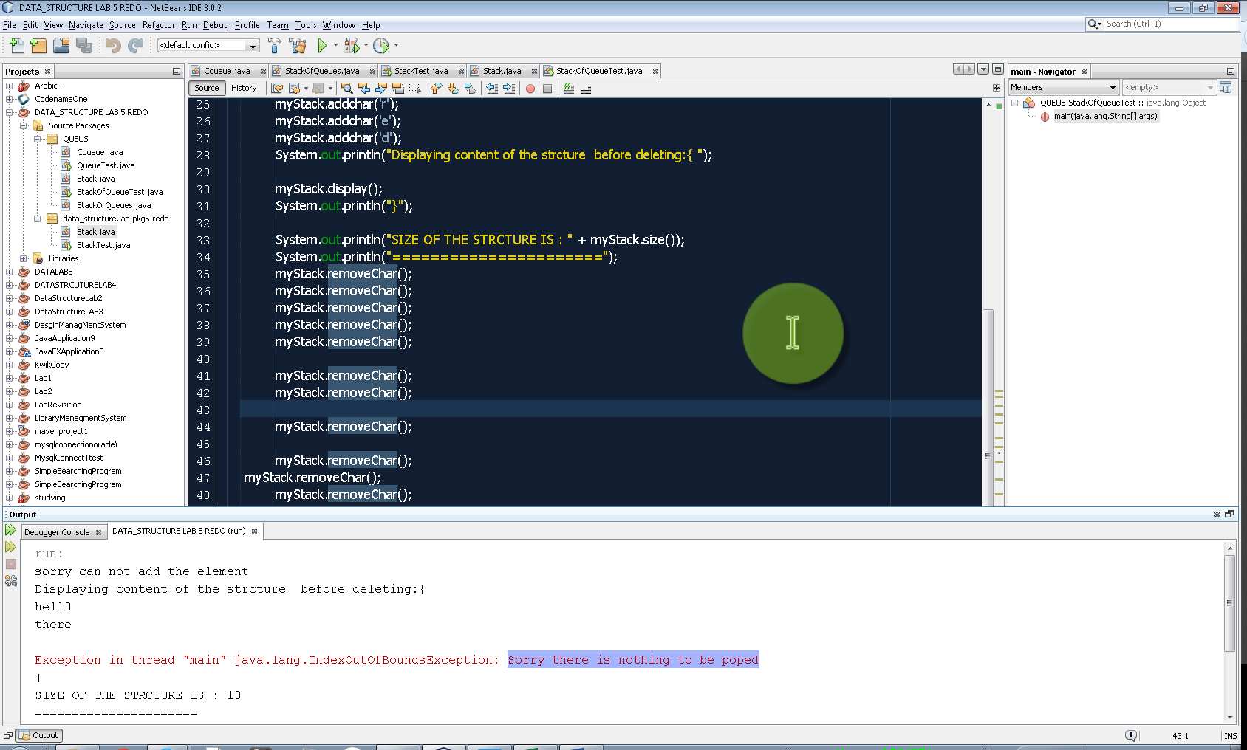Result is explicit call for indexOutofBoundException